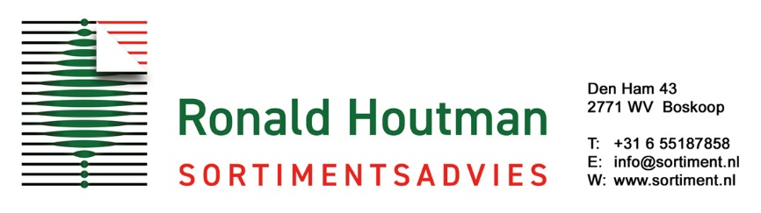

Information needed for EU Plant Breeders’ Rights application

Please send representative photos (of at least the whole plant) of the new variety with this form.

Applicant:

Address:

Tel.: Fax:

e-mail:

If company: owner director other*:

Full names:

Procedural representative - please print and fill in form: Designation of a Procedural Representative
and send original form to address above
Ronald Houtman Sortimentsadvies
Procedural Representative:

Den Ham 43
2771 WV BOSKOOP
Nederland
Address:

+31 6 55187858
Tel.: Fax:
info@sortiment.nl
e-mail:

Plant name (genus and species):

Breeders reference variety denomination (cultivar)*:

Applicant = breeder?* yes / no

(if no, please answer questions below and provide documentary evidence of ownership):

Name of breeder:

Address:

+
+
Tel.: Fax:

e-mail:

Other applications for Plant Breeders’ Rights? Yes* no

*if yes, please answer questions below:

Country:

Application date:

Application number:

Stage:

Plant name:

Origin

Seedling, parents:

Mutation, in which species/cultivar was this mutation discovered:

Where, when (month and year) and how was the new variety raised:

Propagation:

Commercialization

Is the new variety already sold: Within the European Union: Yes* No

* If yes, please state country and delivery date:

Country: Date:

Outside the European Union: Yes* No

* If yes, please state country and delivery date:

Country: Date:

Plant

Approximate height (indicated):

Foliage colour(s):

Flower colour (if conspicuous):

Fruit colour (if conspicuous):

Other ornamental features of the plant:

Similar varieties

Name a similar variety:

State of expression similar variety:

State of expression new variety:

Name a similar variety:

State of expression similar variety:

State of expression new variety:

Name a similar variety:

State of expression similar variety:

State of expression new variety:

